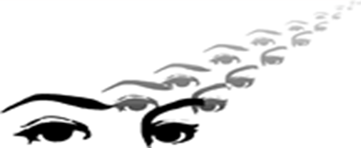
Dr Scott Teske M.B.,B.S. F.R.A.C.O F.R.A.C.S
Surgery of the Eyelids, Orbits & Lacrimal System
Cosmetic Surgery of the Eyelids and Brow

Privacy: The information requested below and relevant health information may be sent to other health professionals (e.g. your anaesthetist) or organisations (e.g. hospitals, pathology) where this is needed to provide your healthcare. As required by the Commonwealth Privacy Act 1988 we request your consent to send this information to these practitioners and organisations. Information will only be sent for the purposes of providing your healthcare.
You may be requested to review the information we have on file about you for the purposes of checking that the information is correct.
I consent to Dr Scott Teske sending my personal and health information to other persons or organisations where this is necessary to provide my healthcare.

Signed____________________________________ Date_____________________________
For more information about your privacy please consult the Commonwealth Privacy Commissioner www.privacy.gov.au

Confidential Patient Information
NAME: Mr/Mrs/Miss/Dr/Ms__________________________________________________
Surname First Name

ADDRESS_________________________________________________________________

___________________________________________________________________________

POSTAL ADDRESS: _______________________________________________________

TELEPHONE Home: _____________________Mobile:_____________________________

EMAIL ___________________________________________________________________

DATE OF BIRTH: _____/_____/_____

MEDICARE CARD NUMBER: _________________________ POSITION # ON CARD: _________

MEDICARE EXPIRY #: _____/_____

Do you have Private Health Insurance? YES/NO
If so, have you been with your insurer for at least 12 months? YES/NO
If yes, please describe your level of cover: _____________________________________

Health Fund: ____________________ Health Fund Number: ______________________

DVA (Veteran Affairs Number) if applicable: __________________________________

DVA Card Colour: _______________________________________________________

Pleas list all previous operations (major organs and or eye operations): __________________________________________________________________________

__________________________________________________________________________

Do you have any Allergies YES / NO
If yes, please specify: _________________________________________________________

Are you a Diabetic? YES /NO
If yes, Type: ________________________________________________________________

Please list any Current
Medication: _________________________________________________________________

Are you taking Aspirin, Warfarin, non-steroidal anti-inflammatory medicines? If so please list:
___________________________________________________________________________

If you proceed with surgery under anaesthetic, can you be supervised overnight by a responsible adult? YES/NO

Who is your regular General Practitioner?
Name: __________________________________Suburb: ____________________________

Would you like us to send correspondence about your consultation with Dr Teske to your GP? YES/NO

Who is your Next of Kin: ______________________________________________________

Relationship: _______________________________Phone:___________________________

Fees:
This is a private billing practice. All fees must be finalized at the time of the service. This practice has a policy of charging a surcharge of up to 25% (+ GST) where appropriate for late payment of accounts. If an account is not settled within three months of the date of surgery and or consultation, these fees may apply.

Signed: ____________________________________ Date: ___________________________

